Lesson 4 Demo 6: Configure Docker to Use External DNS

This section will guide you to:

* Configure Docker Daemon config file to use External DNS

**Step 1:** Create a file named daemon.json, which will be used as the Docker Daemon configuration file, to use external DNS

*sudo nano /etc/docker/daemon.json*



**Step 2:** In *daemon.json file*, add the following *dns* key with one or more IP addresses:

"dns": ["8.8.8.8", "8.8.4.4"]

***Note:***Do write the code snippet shown in the screenshot below rather than copying it on the terminal. Do not forget to add a comma after each value pair.

Ex: "storage-driver": "overlay2"**,** "dns": ["8.8.8.8", "8.8.4.4"]

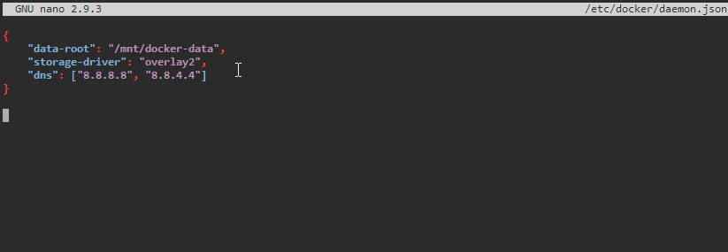

**Note**: Press **Ctrl+X** to exit the editor. Then type **Y** and press **Enter** to save the file.

**Step.3:** Use the following command to restart the Docker Daemon:

*sudo service docker restart*



**Step 4:** Use the following command to test the DNS by looking up an external domain:

*sudo docker run nicolaka/netshoot nslookup google.com*

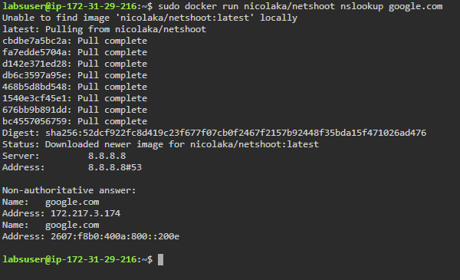

**Step 5:** Use the following command to run a container with a custom DNS and test it by doing an *nslookup*:

*sudo docker run --dns 8.8.4.4 nicolaka/netshoot nslookup facebook.com*

